Okaybiking
More Than Just a Bike Ride
Johan and Niels have cycled thousands of kilometers together. What lies behind these bikepacking trips? In this interview, I ask Johan what it's like to experience these cycling adventures and what they mean to him.
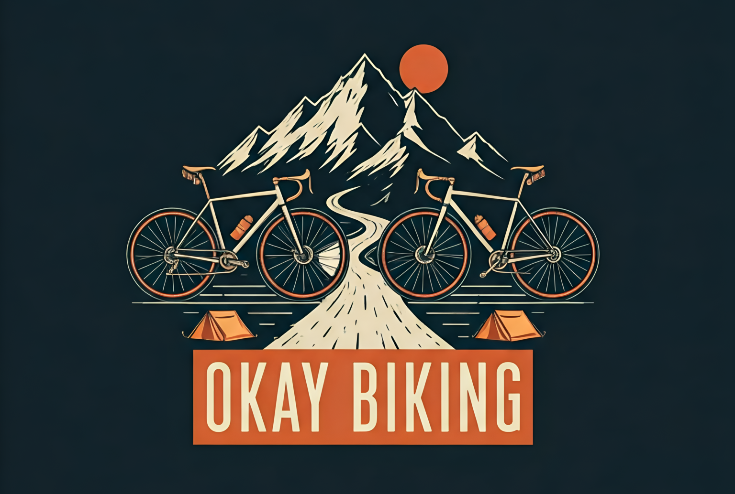
{ Logo Okay Biking }

The Beginning
Look, here’s how it went...
I work as a youth worker, and one afternoon I was sitting across from a colleague who was crazy about cycling. Out of the blue, he said, “Hey, want to come along? Let’s cycle to the Mediterranean Sea.” So I jokingly replied, “Well, I think Paris is far enough.” And he said, “That’s fine too.”
Right after that, I called my wife and said, “I’m going to cycle to Paris.”
“You’re completely nuts, do whatever you want,” she said.
And that’s how it all started—because of that comment from Niels, my colleague, who’s now my regular cycling buddy. After that, we bought a bike and bags for me, because I didn’t have anything yet. We ended up cycling to Paris, and later on, we founded Okaybiking.

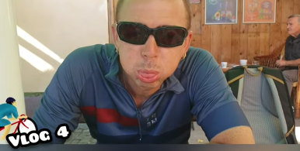
{ Johan in a Café }

Motivation or discipline?
You know what it is…
You have good days and not-so-good days. Sometimes you’re completely drained and really not in the mood, but you’ve already planned the route—and it just has to be cycled.
So what keeps me going then? It’s the fun along the way, the things you see, the landscapes, the places you pass through, the people you meet, the different cultures you encounter, the way other people live.
Along the way, people sometimes call you crazy for doing this—and honestly, that kind of motivates me. The crazier it is, the better.
Yeah… it’s really that feeling of freedom. You’re always working, stuck in a kind of rhythm, the daily grind of private life, work, and… you know, I’ve also spent years in school. But when you’re on that bike—you don’t have to take anyone into account. You can do whatever you want.
It’s just the route from A to B, and the next day, again. That’s what makes it so interesting: all the people you meet, the environment.
Sometimes we take a rest day in a beautiful place and soak up some culture, maybe even go for a mountain hike. You reach places on a bike that you’d never get to by car. You really see a lot of Europe—and soon, Asia too.

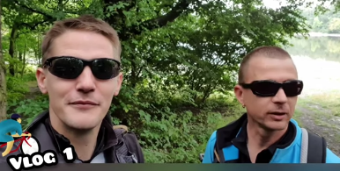
{ Johan and Niels on Their Way to Venice}

Discovering new places is just awesome.
I still remember when we were cycling from France and crossed into Spain—there was a heatwave going on, and you immediately feel the difference. The roads change, but so does the temperature. France, even when it's hot, is still relatively humid. Spain, on the other hand, is bone dry.
There was a heatwave… and now I totally get why they call it that. The air felt like it had no oxygen, and there was this constant stream of hot wind blowing right into your face.
Then, for example, after climbing for two hours, completely exhausted, you finally reach the top of a mountain. And the view—over the Pyrenees or the Alps—it’s just stunning. That’s when you know: I’m taking a break now, and then I get to fly downhill at 60, 70 kilometers per hour.
And when you’re back down in a valley, suddenly everything’s green. In the next valley, it might be pouring rain with hail, and then up on the next ridge it’s completely dry again. It’s so strange.
You experience so much… It’s such a unique way to spend a holiday.

What’s it like to be stuck with just one person for such a long time?
That’s a really good question…
It’s… yeah, you know, you just have to be able to sense each other. That first cycling trip to Paris was still a bit of a gamble. How would it go? Would we be in sync?
Uh… Look, Niels and I get along really well, and we can tell when the other is struggling—we’re constantly motivating each other to keep riding, to push through.
You’re away from home for a long time too, although I personally don’t struggle much with that. I try to save my energy for the cycling.

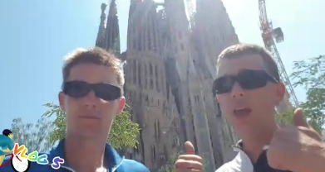
{ Johan and Niels at the Sagrada Família }

Cycling for a good cause
I do these cycling trips because it’s a challenge. We started in Maastricht, and we keep going further and further. This year, we’re cycling from Dubrovnik to Athens. The year after that, we’ll go from Athens to Istanbul, and then we want to cycle to Asia. We plan to spend 2-3 months heading towards China, Nepal, Vietnam. We’re also cycling for a good cause. We’ve cycled for different charities. Both Niels and I work at Welzijnskwartier, so we always want to cycle for a social cause. Preferably something that can be carried out in our area or a foundation that is based in our area. For example, we cycled for Adamas, which supports children with cancer or families who have been affected by cancer, including siblings. Adamas doesn’t receive any funding, so if you can cycle and raise 2000 euros to buy toys for the children… that’s really great, both for the children and for us. We’ve also cycled for Make A Wish, for a wish of someone who lived in our area. This year, we’ll cycle for Stichting Opkikker, another good cause with a social heart. We also cycled for the Jeugdsportfonds, a fund where parents can apply for money so their child can participate in a sport because they can’t afford it themselves. So it’s nice that the money directly reaches the target group. That means we won’t cycle for Amnesty International or another big cause. We don’t cycle for the director’s car. We want the money to go directly to the foundation. That’s a condition we have.
Before we start cycling, we always get in touch and have a conversation. We explain our plan and see how they react. Based on that, we then make a decision on whether to go ahead with it or not. Additionally, we do it for a larger audience. It doesn’t matter to me if the money goes to a Dutch person, an asylum seeker, or a young, single foreign minor. We don’t want to make any distinction. You know, every person is equal.

Written by Chelsea van Weeghel
Link:
https://www.youtube.com/@OkayBiking

